**EXPERIMENT – 3**

**EXP NO 3: CREATE A SIMPLE CLOUD SOFTWARE APPLICATION FOR PROPERTY BUYING & RENTAL PROCESS (IN CHENNAI CITY) USING ANY CLOUD SERVICE PROVIDER TO DEMONSTRATE SAAS.**

**DATE:**26/09/25

**AIM:**

To Create a simple cloud software application for Chennai Property Hub

(In Chennai city) using any Cloud Service Provider to demonstrate SaaS.

**PROCEDURE:**

**step1:** Go to zoho.com.

**step 2:** Log into the zoho.com.

**step 3:** Select one application step.

**step4:** Enter application name as Chennai Property Hub.

**step 5:** Created new application Chennai Property Hub.

**step 6:** Select one form

**step 7:** The software has been created.

**OUTPUT:**

**FORM 1 –User Registration Form**

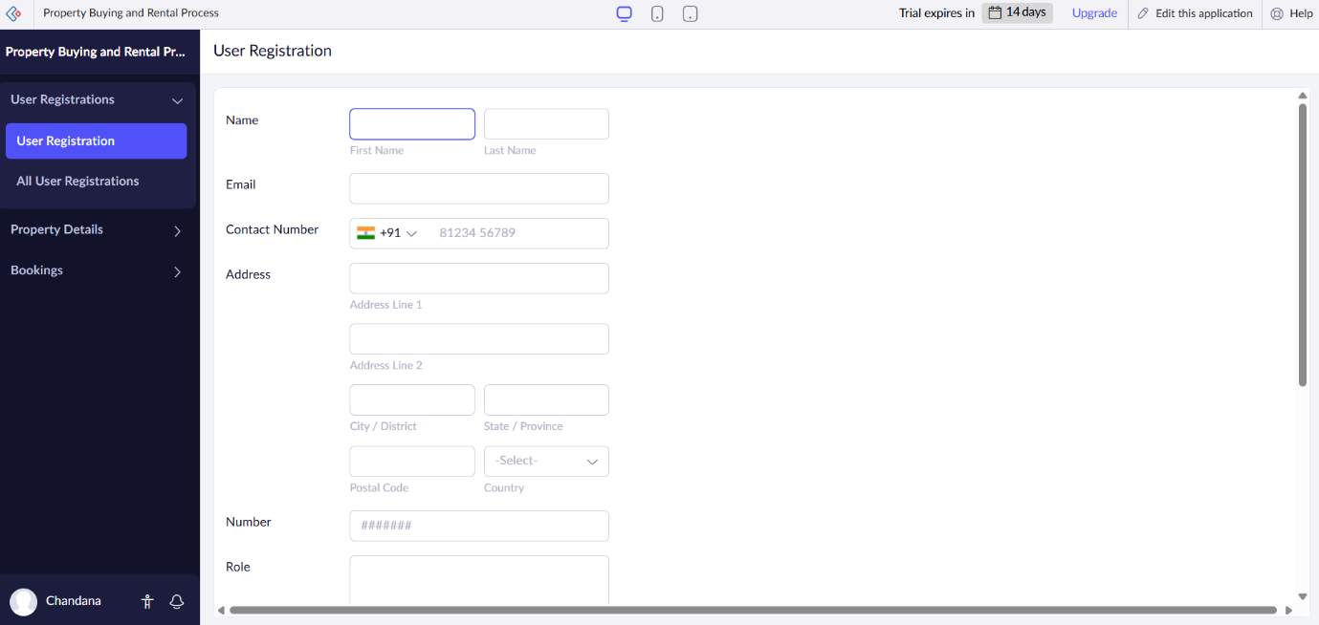

**FORM 2 –Property Details Form**

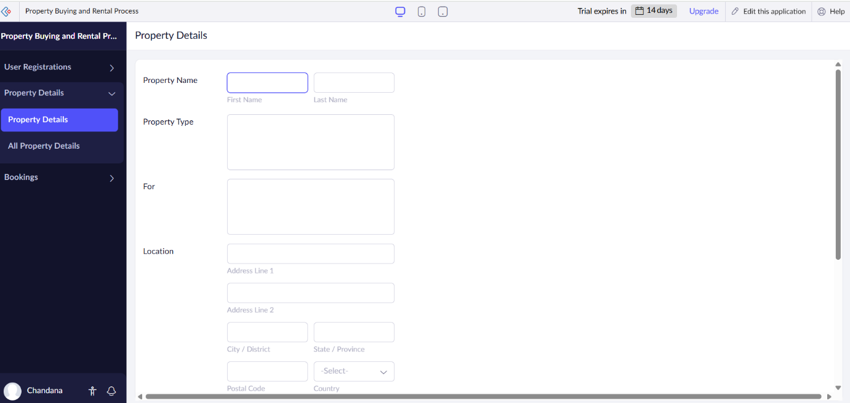

**FORM 3 –Booking Form**

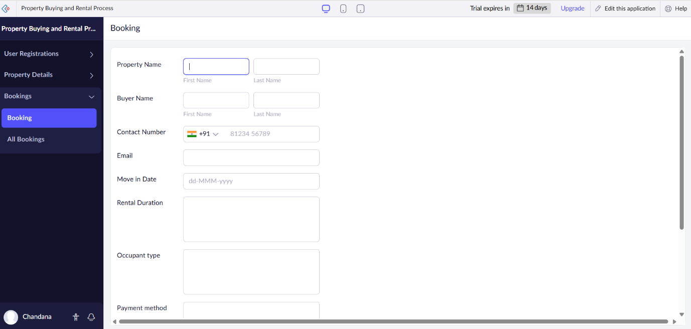

**FORM 1 – User Registration Form**

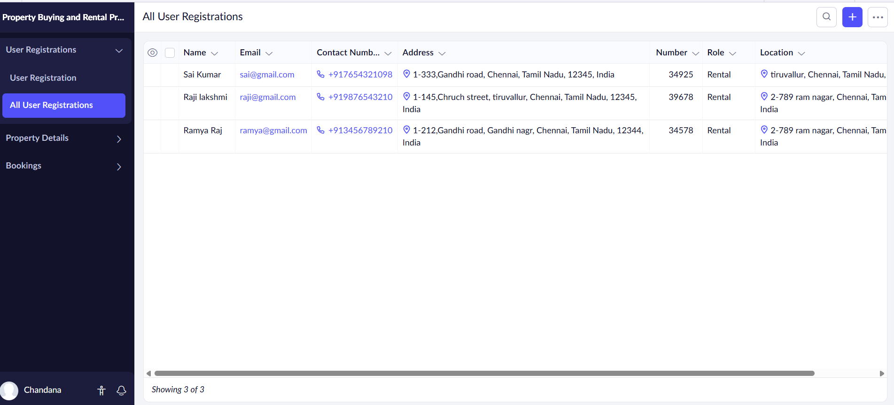

**FORM 2 – Property Details Form**

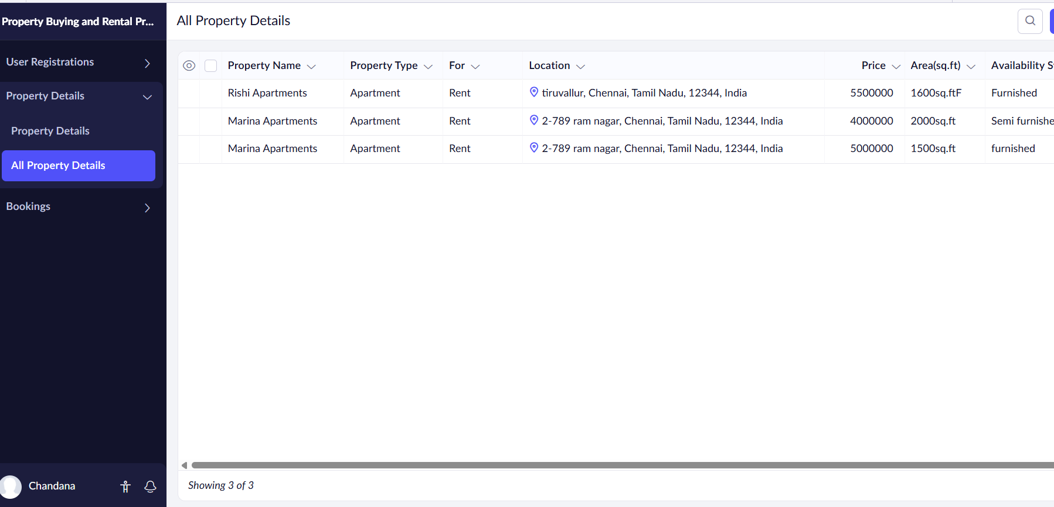

**FORM 3 – Booking Form**

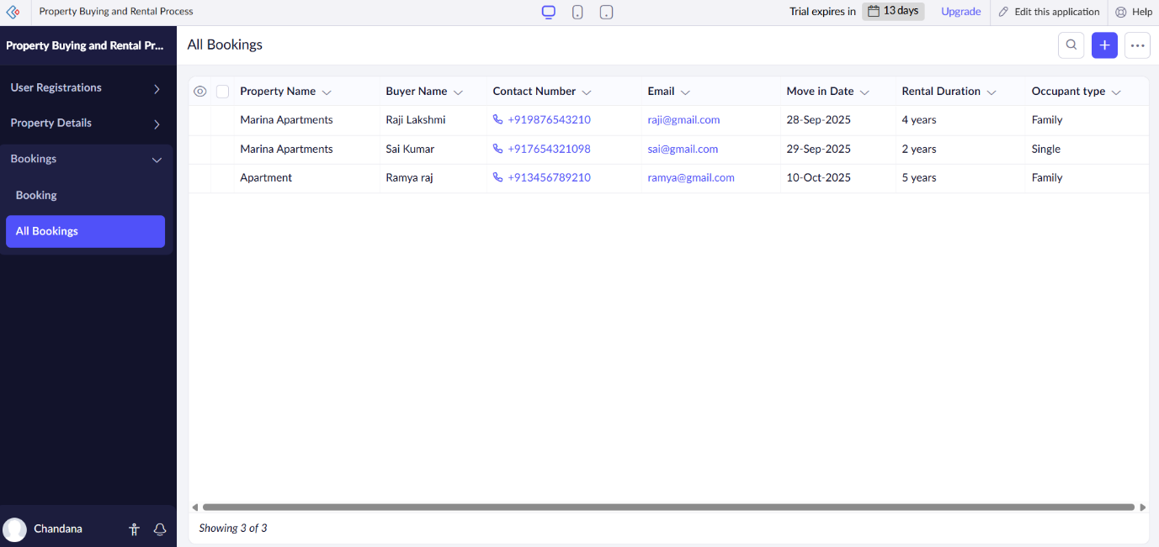

**RESULT:**

The **Chennai Property Hub** application was successfully created using **Zoho Creator (Cloud SaaS platform)** with the following forms:

* **User Registration Form**
* **Property Details Form**
* **Booking Form**

This demonstrates **SaaS**, as customers and owners can access the system online, view properties, submit applications, and track the status entirely via the cloud without installing software.